**Build reports**

In Power BI Desktop **Report** view, you can build visualizations and reports. The **Report** view has six main areas:

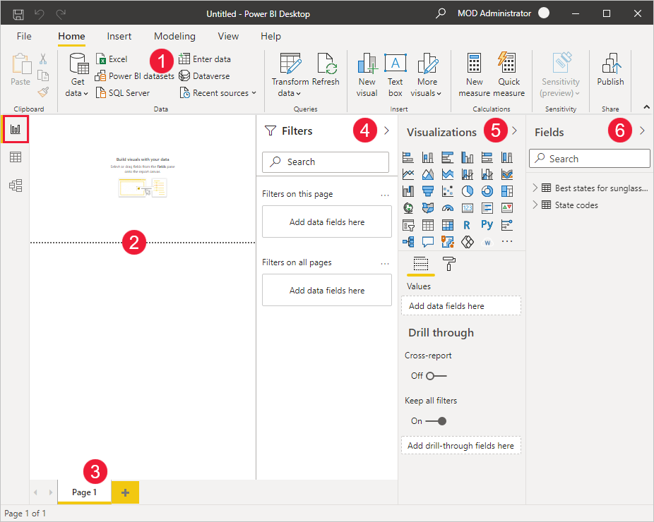

1. The ribbon at the top, which displays common tasks associated with reports and visualizations.
2. The canvas area in the middle, where visualizations are created and arranged.
3. The pages tab area at the bottom, which lets you select or add report pages.
4. The **Filters** pane, where you can filter data visualizations.
5. The **Visualizations** pane, where you can add, change, or customize visualizations, and apply drillthrough.
6. The **Fields** pane, which shows the available fields in your queries. You can drag these fields onto the canvas, the **Filters** pane, or the **Visualizations** pane to create or modify visualizations.

You can expand and collapse the **Filters**, **Visualizations**, and **Fields** panes by selecting the arrows at the tops of the panes. Collapsing the panes provides more space on the canvas to build cool visualizations.

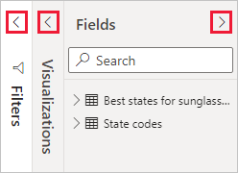

To create a simple visualization, just select any field in the fields list, or drag the field from the **Fields** list onto the canvas. For example, drag the **State** field from **Best states for sunglass sales** onto the canvas, and see what happens.

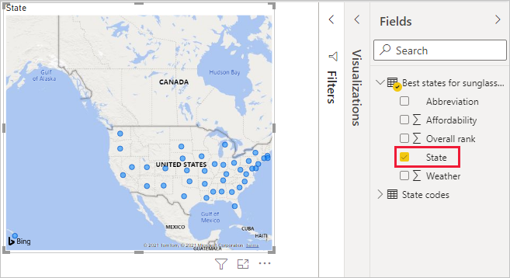

Look at that! Power BI Desktop recognized that the **State** field contained geolocation data and automatically created a map-based visualization. The visualization shows data points for the 40 states from your data model.

The **Visualizations** pane shows information about the visualization and lets you modify it.

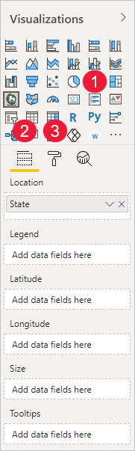

1. The icons show the type of visualization created. You can change the type of a selected visualization by selecting a different icon, or create a new visualization by selecting an icon with no existing visualization selected.
2. The **Fields** option in the **Visualization** pane lets you drag data fields to **Legend** and other field wells in the pane.
3. The **Format** option lets you apply formatting and other controls to visualizations.

The options available in the **Fields** and **Format** areas depend on the type of visualization and data you have.

You want your map visualization to show only the top 10 weather states. To show only the top 10 states, in the **Filters** pane, hover over **State is (All)** and expand the arrow that appears. Under **Filter type**, drop down and select **Top N**. Under **Show items**, select **Bottom**, because you want to show the items with the lowest numerical ranks, and enter *10* in the next field.

Drag the **Weather** field from the **Fields** pane into the **By value** field, and then select **Apply filter**.

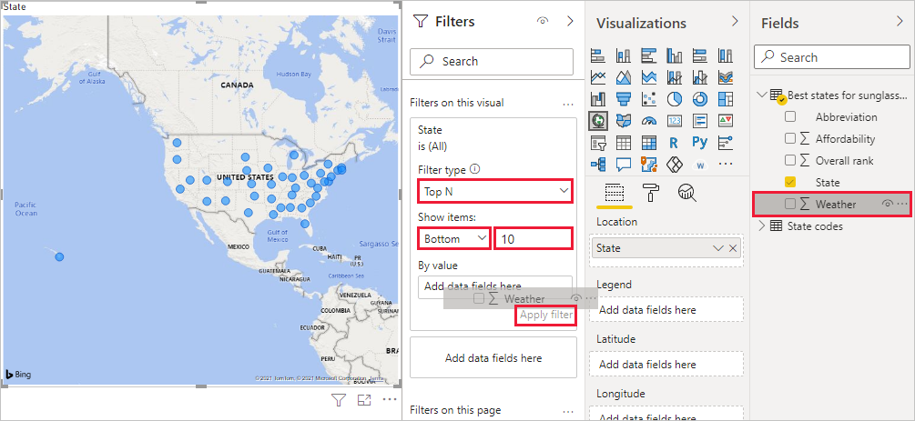

You now see only the top 10 weather states in the map visualization.

Retitle your visualization by selecting the **Format** icon in the **Visualization** pane, selecting **Title**, and typing *Top 10 weather states* under **Title text**.

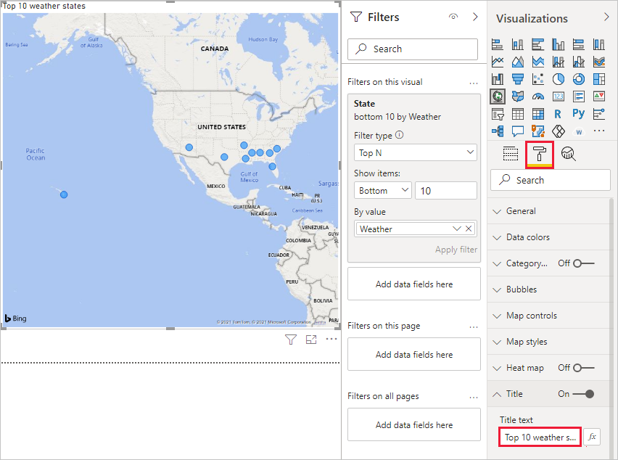

To add a visualization that shows the names of the top 10 weather states and their ranks from 1 to 10, select a blank area of the canvas and then select the **Column chart** icon from the **Visualization** pane. In the **Fields** pane, select **State** and **Weather**. A column chart shows the 40 states in your query, ranked from highest to lowest numerical rank, or worst to best weather.

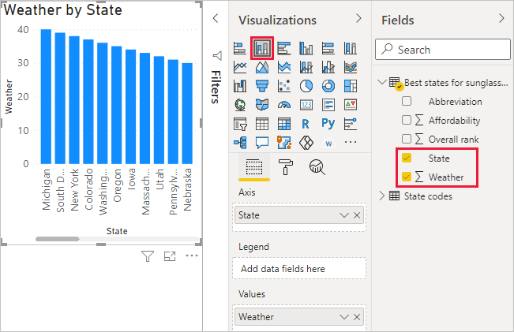

To switch the order of the ranking so that number 1 appears first, select the **More options** ellipsis at the upper right of the visualization, and select **Sort ascending** from the menu.

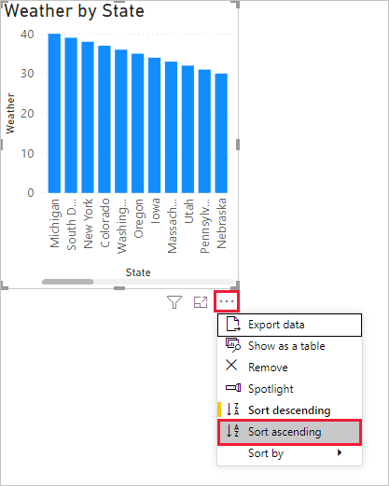

To limit the table to the top 10 states, apply the same bottom 10 filter as you did for the map visualization.

Retitle the visualization the same way as for the map visualization. Also in the **Format** section of the **Visualization** pane, change **Y axis** > **Axis title** from **Weather** to *Weather ranking* to make it more understandable. Then, turn the **Y axis** selector to **Off**. Turn the **Zoom slider** to **On** and turn **Data labels** to **On**. Finally, adjust the zoom slider along the Y axis until the stacked columns fill the chart.

Now, the top 10 weather states appear in ranked order along with their numerical rankings.

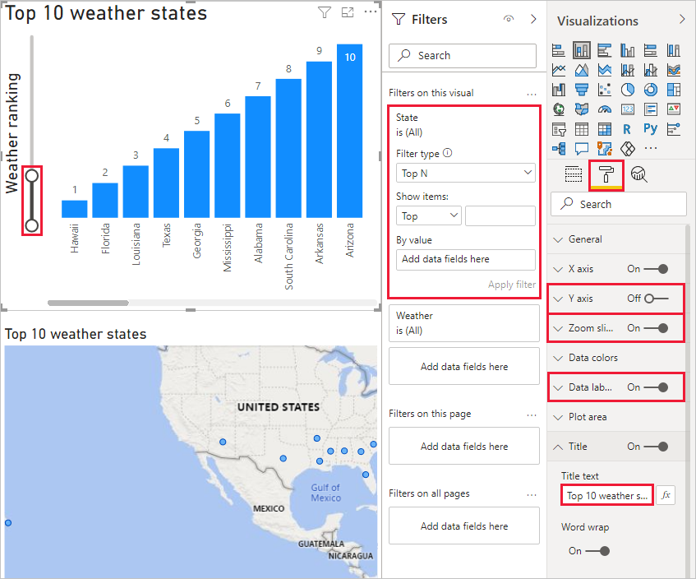

You can make similar or other visualizations for the **Affordability** and **Overall ranking** fields, or combine several fields into one visualization. There are all sorts of interesting reports and visualizations you can create. These **Table** and **Line and clustered column chart** visualizations shows the top 10 weather states along with their affordability and overall rankings:

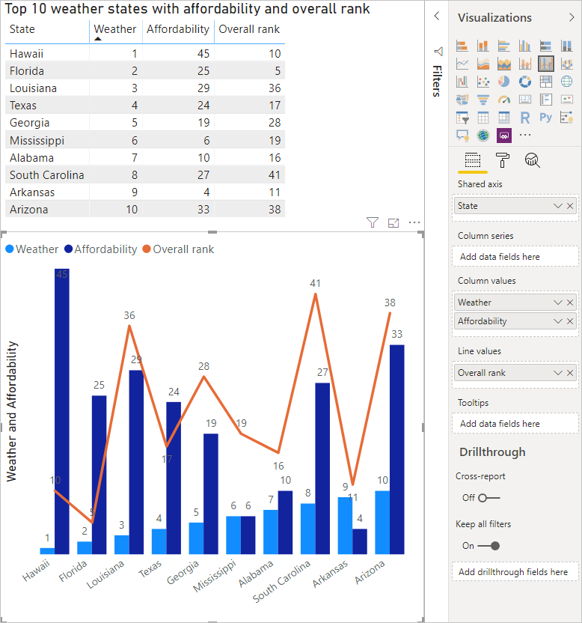

You can show different visualizations on different report pages. To add a new page, select the **+** symbol next to the existing pages on the pages bar, or select **Insert** > **New Page** in the **Home** tab of the ribbon. To rename a page, double-click the page name in the pages bar, or right-click it and select **Rename Page**, and then type the new name. To go to a different page of the report, select the page from the pages bar.

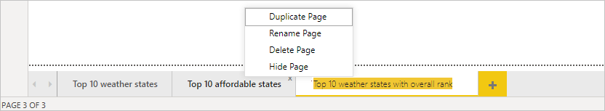

You can add text boxes, images, and buttons to your report pages from the **Insert** group of the **Home** tab. To set formatting options for visualizations, select a visualization and then select the **Format** icon in the **Visualizations** pane. To configure page sizes, backgrounds, and other page information, select the **Format** icon with no visualization selected.

When you finish creating your pages and visualizations, select **File** > **Save** and save your report.

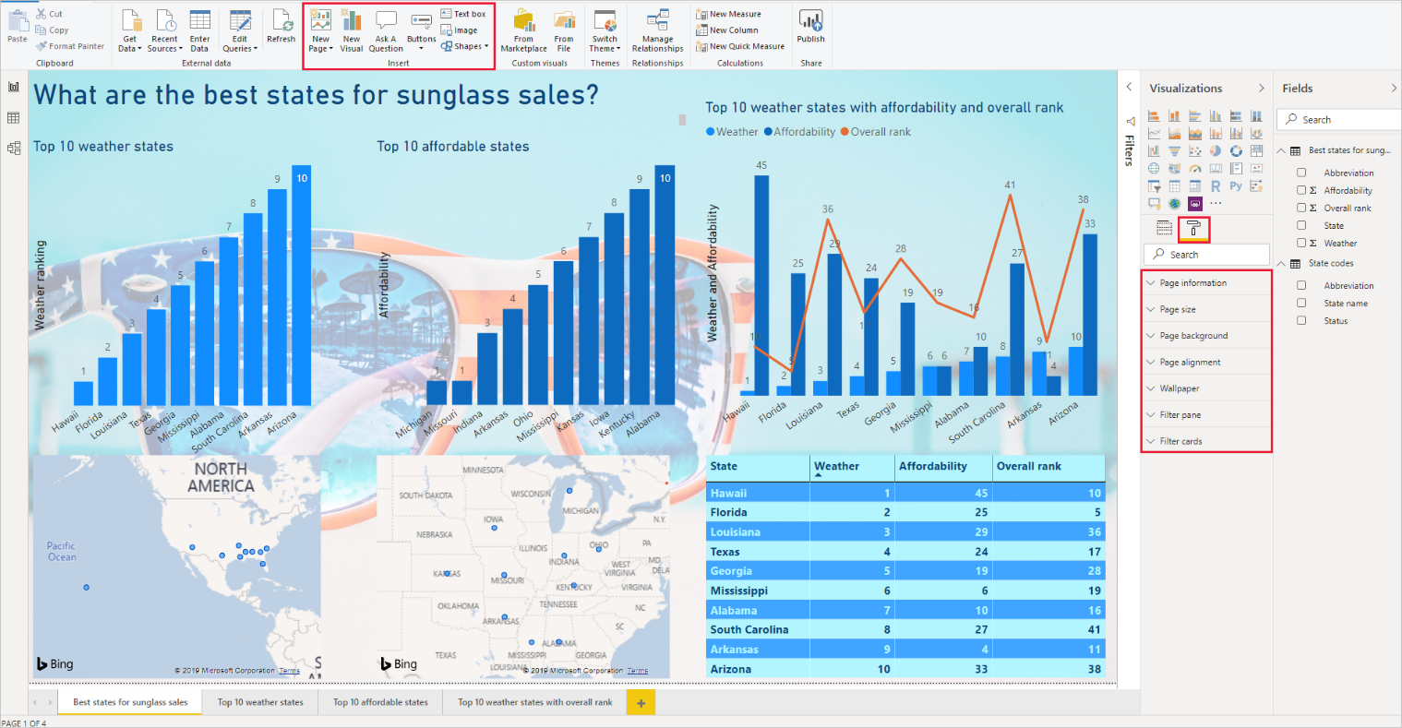

For more information about reports, see [Report View in Power BI Desktop](https://docs.microsoft.com/en-us/power-bi/create-reports/desktop-report-view).

**Share your work**

Now that you have a Power BI Desktop report, you can share it with others. There are a few ways to share your work. You can distribute the report *.pbix* file like any other file, you can upload the *.pbix* file from the Power BI service, or you can publish directly from Power BI Desktop to the Power BI service. You must have a Power BI account to be able to publish or upload reports to Power BI service.

To publish to the **Power BI** service from Power BI Desktop, from the **Home** tab of the ribbon, select **Publish**.

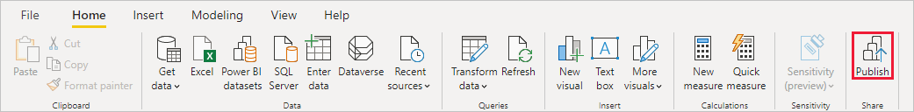

You may be prompted to sign in to Power BI, or to select a destination.

When the publish process is complete, you see the following dialog:

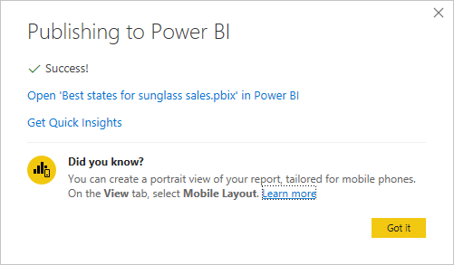

When you select the link to open the report in Power BI, your report opens in your Power BI site under **My workspace** > **Reports**.

Another way to share your work is to load it from within the **Power BI** service. Go to *https://app.powerbi.com* to open Power BI in a browser. On your Power BI **Home** page, select **Get data** at lower left to start the process of loading your Power BI Desktop report.

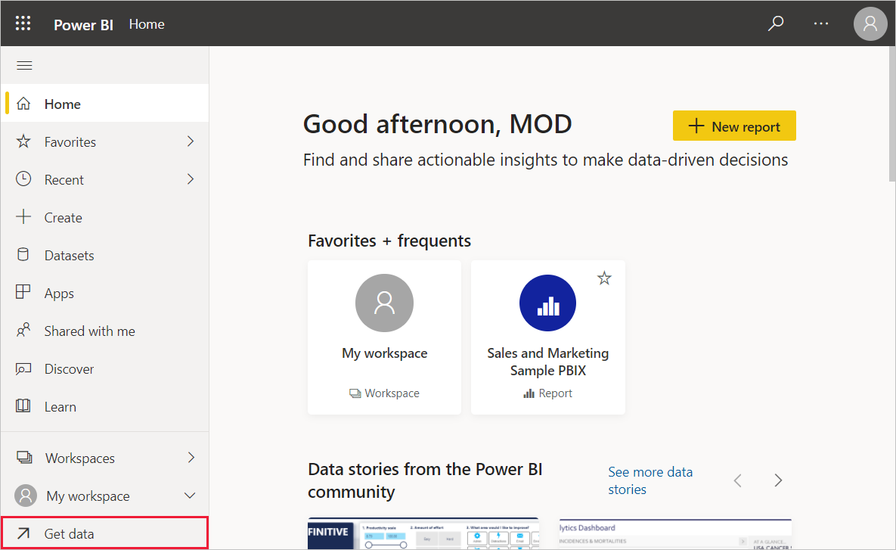

On the next page, select **Get** from the **Files** section.

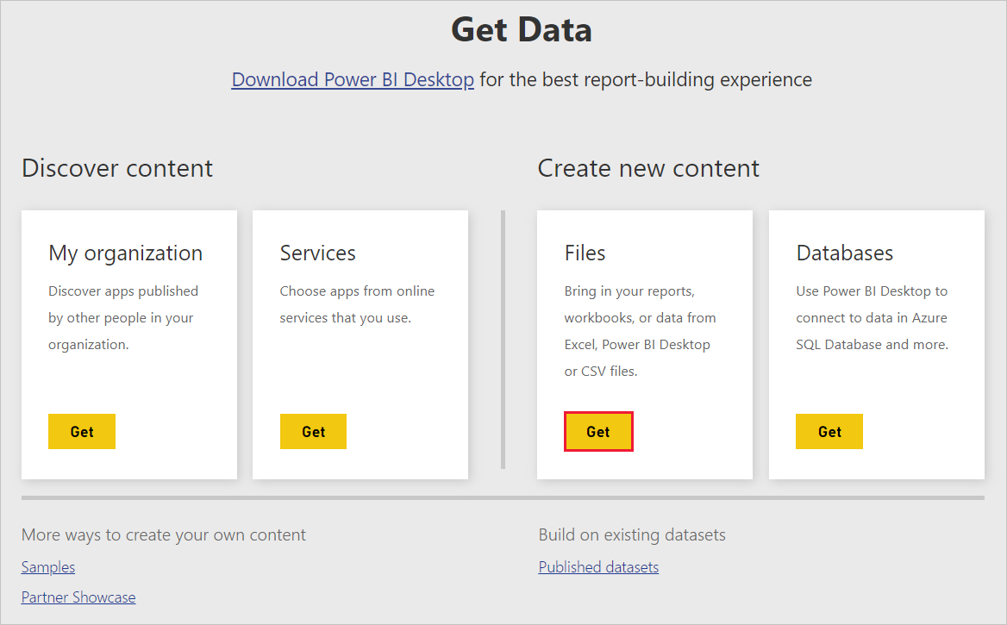

On the next page, select **Local File**. Browse to and select your Power BI Desktop *.pbix* file, and select **Open**.

After the file imports, you can see it listed under **My workspace** > **Reports** in the left pane of the Power BI service.

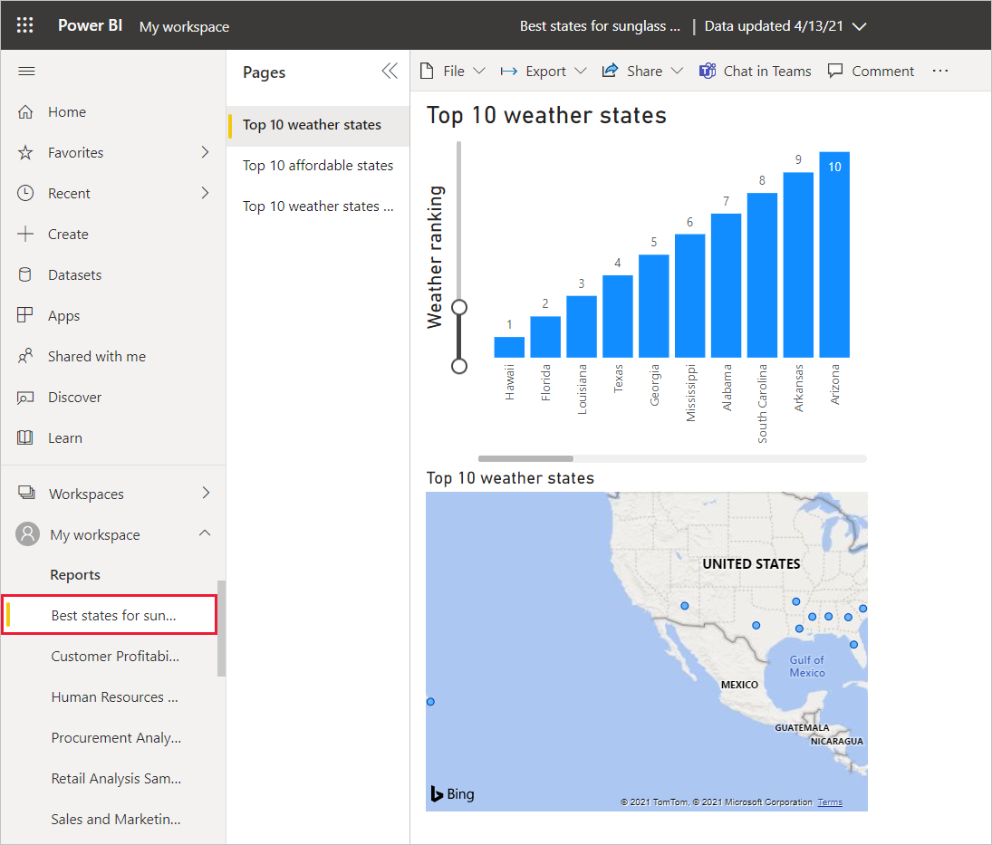

When you select the file, the first page of the report appears. You can select different pages from the tabs at the left of the report.

You can make changes to a report in the **Power BI** service by selecting **More options** > **Edit** from the top of the report canvas.

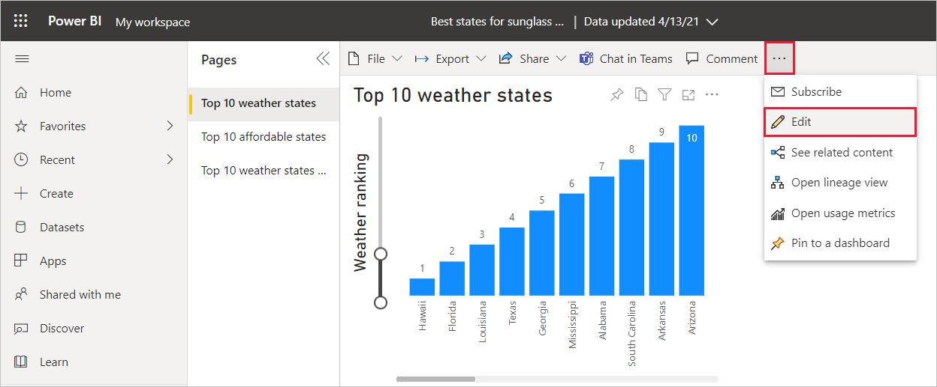

To save your changes, select **File** > **Save a copy**.

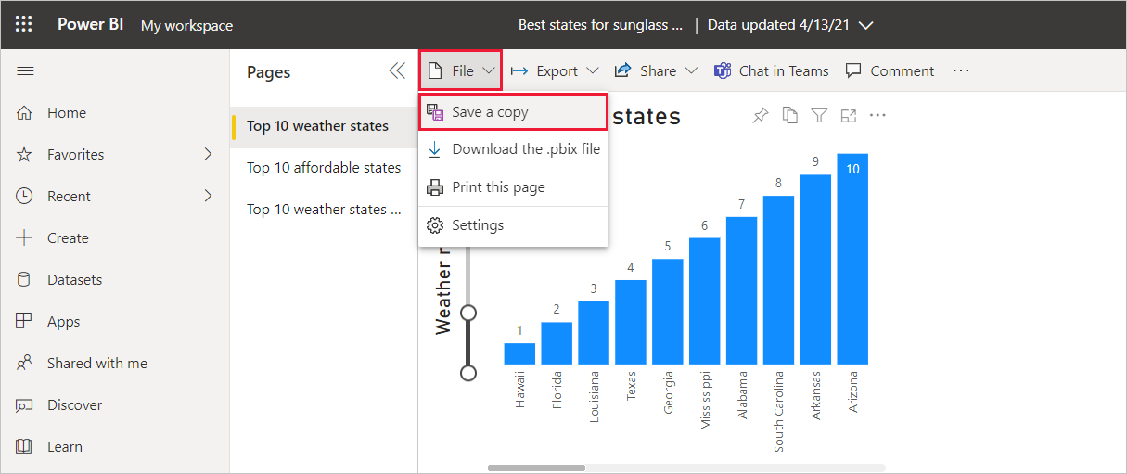

There are all sorts of interesting visuals you can create from your report in the **Power BI** service, which you can pin to a *dashboard*. To learn about dashboards in the **Power BI** service, see [Tips for designing a great dashboard](https://docs.microsoft.com/en-us/power-bi/create-reports/service-dashboards-design-tips). For more information about creating, sharing, and modifying dashboards, see [Share a dashboard](https://docs.microsoft.com/en-us/power-bi/collaborate-share/service-share-dashboards).

To share a report or dashboard, select **Share** > **Report** at the top of the open report or dashboard page, or select the **Share** icon next to the report or dashboard name in the **My workspace** > **Reports** or **My workspace** > **Dashboards** lists.

Complete the **Share report** or **Share dashboard** screen to send an email or get a link to share your report or dashboard with others.

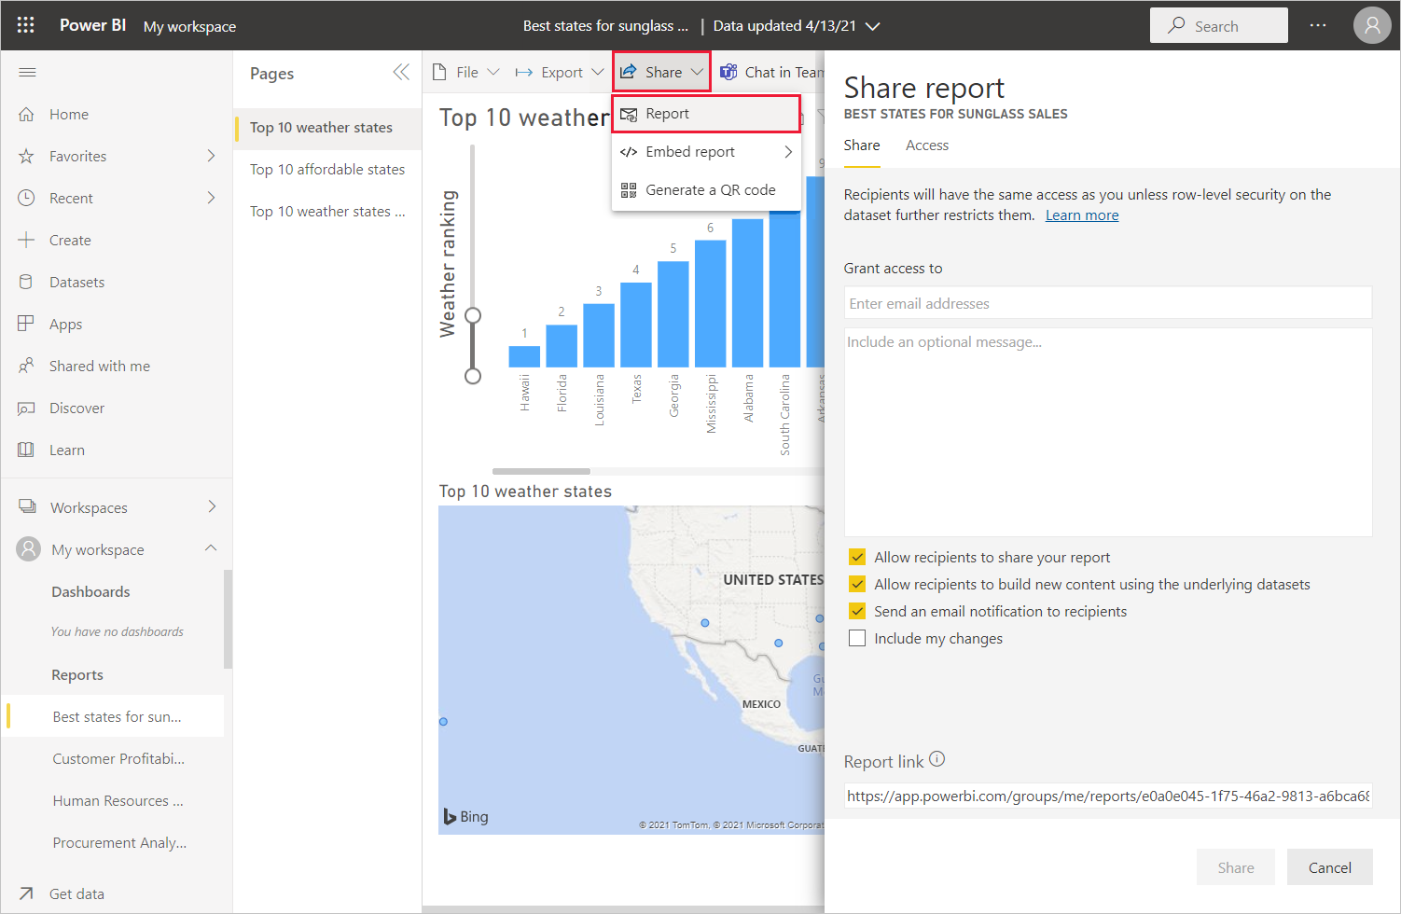

There are many compelling data-related mash-ups and visualizations you can do with Power BI Desktop and the Power BI service.